Calaveras County Fair – Commercial Vendor Information – May 14-17, 2026
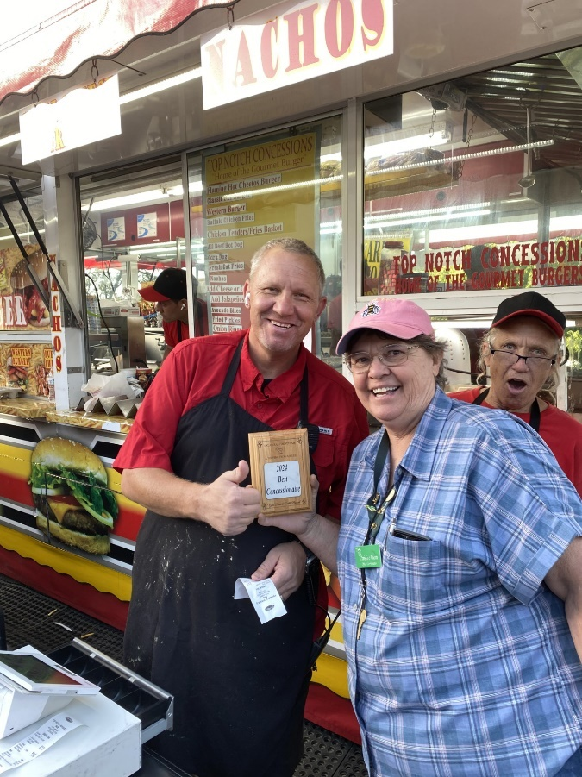

Thank you for your interest in being a commercial vendor at the Calaveras County Fair! Please note that submitting this application does not guarantee booth space.
For questions about the application, call the Fair office at (209) 736-2561 or email vendor@frogtown.org.

Booth Fees
Outdoor Booths:
- 10’ x 10’: $550
- 10’ x 20’: $900
Indoor Booths:
- 10’ x 10’: $700
- 10’ x 20’: $1,100
Craft Tables:
- Indoor 8’: $300
- Outdoor 8’: $200
Food Concessions: $500 plus 25% of daily receipts, whichever is greater.
Note: “Craft” vendor booths are limited and must feature handmade items only. No commercial products are eligible. Indoor buildings are locked at night and supervised during opening hours.

Vendor Admission & Parking:
Booth fees include admission and parking passes:
- 10’ x 10’: 8 single-day admission passes & 4 single-day parking passes
- 10’ x 20’: 16 single-day admission passes & 8 single-day parking passes
Additional passes:
- Admission: $6 per person per day
- Parking: $5 per day or $20 for a 4-day parking pass

RV & Stock Parking:
- Full hook-up RV site: $350 (includes 2 vehicle passes)
- Dry (non-hookup) campsite: $100
- Stock truck parking: $100
- Stock truck parking with power: $200
RV and stock parking spaces are limited. Contact the Fair office to reserve.

Booth Requirements:
- Vendors must provide their own tents, tables, and chairs.
- Tents must be fire-resistant or treated and labeled accordingly.
- Electricity is available within limits; contact the Fair office for excessive needs.

Insurance:
All vendors must provide a minimum of $1,000,000 general liability insurance per occurrence, naming the Calaveras County Fair as additional insured.
- If you cannot provide insurance, coverage can be purchased through California Fairs Services Authority (CFSA) with assistance from the Fair office.

Fair Hours:
- Thursday & Sunday: 8:00 AM – 11:00 PM
- Friday & Saturday: 8:00 AM – 12:00 AM
Booth Staffing Recommendations:
- Indoor booths: 10:00 AM – 10:00 PM
- Outdoor booths: 10:00 AM – 10:00 PM

Discounts
A 20% discount is available for vendors who reside in Calaveras County.
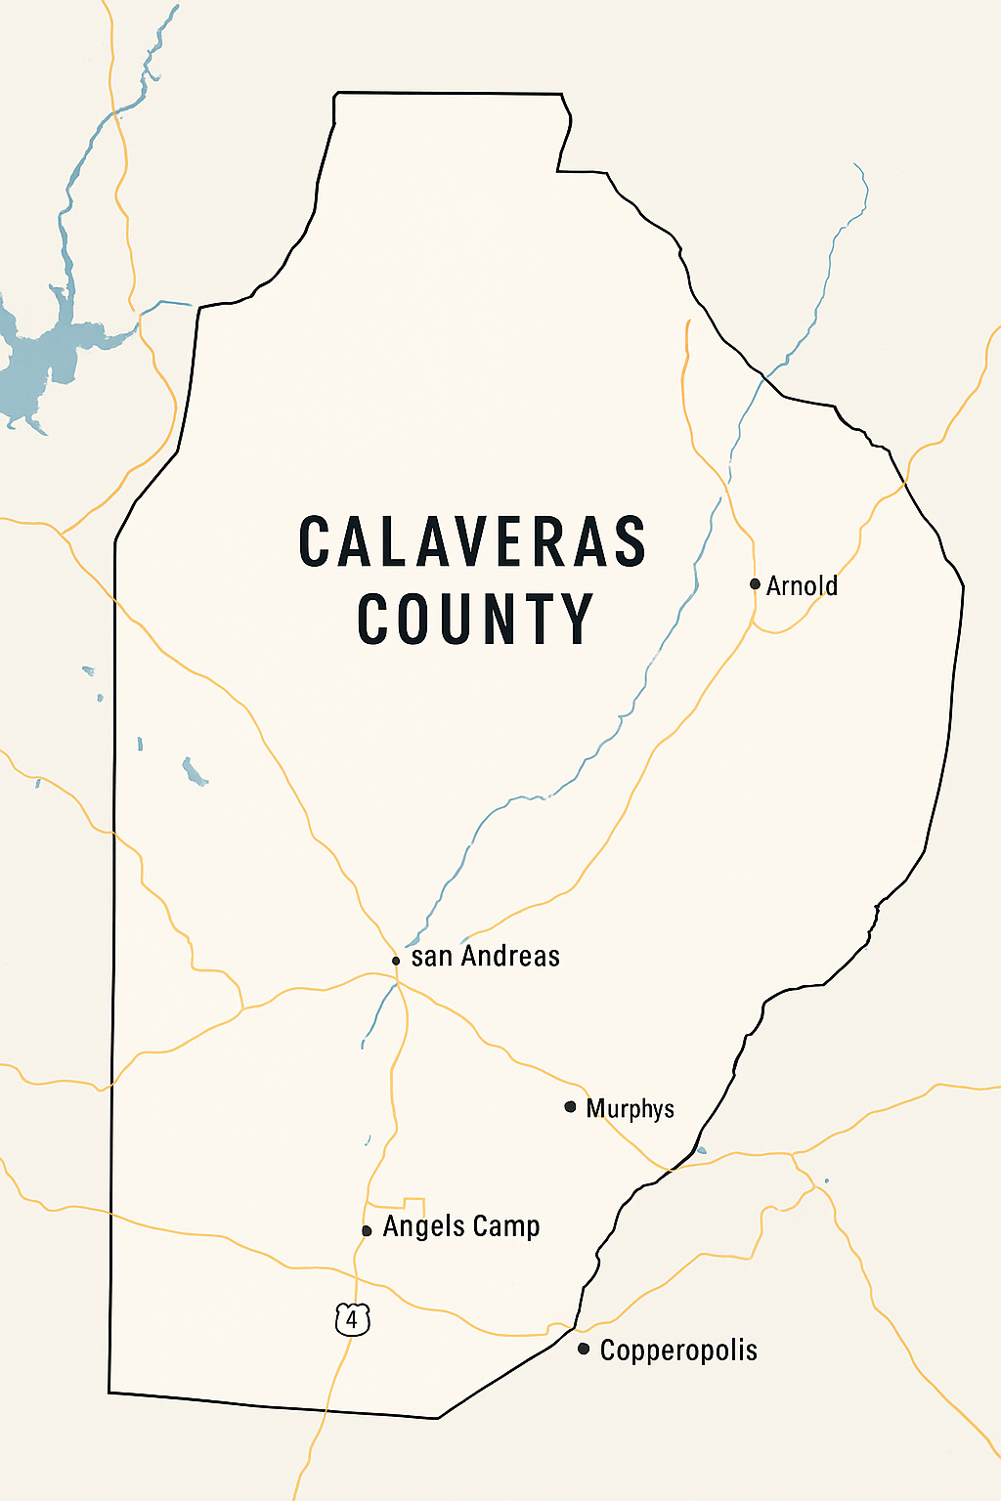

Calaveras County Fair – Vendor Application 2026
Thank you for your interest in being a commercial vendor at the Calaveras County Fair!
Submitting this application does not guarantee booth space. The Fair does not offer exclusivity to vendors. However, the Fair is known for its variety of booths and may limit booths if duplication affects the integrity of the show.
For questions, contact:
Phone: (209) 736-2561
Email: vendor@frogtown.org

Vendor Information
Vendor/Business Name: | _____________________________
Contact Name: | _____________________________
Mailing Address: | _____________________________
City / State / Zip: | _____________________________
Phone: | _____________________________
Email: | _____________________________
Website / Social Media: | _____________________________

Booth & Table Selection
Outdoor Booths:
- ☐ 10’ x 10’ – $550
- ☐ 10’ x 20’ – $900
Indoor Booths:
- ☐ 10’ x 10’ – $700
- ☐ 10’ x 20’ – $1,100
Craft Tables:
- ☐ Indoor 8’ – $300
- ☐ Outdoor 8’ – $200
Food Concessions:
- ☐ $500 + 25% of daily receipts
“Craft” booths are limited to handmade items only. Indoor buildings are locked at night with supervision.

Vendor Admission & Parking
Included with booth:
- 10’ x 10’: 8 single-day admissions & 4 parking passes
- 10’ x 20’: 16 single-day admissions & 8 parking passes
Additional passes:
- Admission: $6/person/day
- Parking: $3/day or $12 for 4-day pass
RV / Stock Parking:
- ☐ Full hook-up RV: $350
- ☐ Dry (non-hookup) RV: $100
- ☐ Stock truck: $100
- ☐ Stock truck with power: $200
Limited spaces – reserve early!

Insurance Requirement
- All vendors must provide $1,000,000 general liability insurance per occurrence, naming the Calaveras County Fair as additional insured.
- Insurance may be purchased via CFSA with assistance from the Fair office.
- ☐ I have insurance
- ☐ I will purchase insurance through CFSA

Electrical & Special Requests
- Electricity: ☐ Yes ☐ No
- Description of electrical / special needs: _____________________________

Products / Services
- Please list all items you will be selling:

Craft booths: All items must be handmade. No commercial products allowed.

Booth Staffing
- Indoor & Outdoor booths are recommended to be staffed: 10:00 AM – 10:00 PM daily.

Discount
- ☐ I reside in Calaveras County (20% discount applies)

Agreement & Signature
I, the undersigned, have read and understand the Calaveras County Fair Vendor Policies, including insurance, booth requirements, and booth hours. I agree to comply with all rules and regulations.
Signature: ___________________________ Date: ________________

Submit completed application with payment to:
Calaveras County Fair Office
Email: vendor@frogtown.org
Mail: PO Box 489, Angels Camp CA 95222

`The Calaveras County Fair is seeking experienced operators with quality presentation; consideration will be given to those with unique items. The sale of certain items including but not limited to the following is prohibited: weapons, drug paraphernalia, provocative or suggestive items, graphic images that may offend a family-friendly audience.
