Calaveras County
Fair &
Jumping Frog Jubilee
May 18-21, 2023
If you Grew It, Drew It or Sewed It, you should Show It!
Special children’s entry program
Calaveras County Fair & Jumping Frog Jubilee
If you grew it, drew it, or sewed it; you should show it!
General Information
This special competition is open to students who are in preschool through the sixth grade. Entries are delivered to Tom Sawyer Hall with the entry form on May 9th noon to 7 p.m. or May 10th, 10 a.m. to 6p.m. All entries must be picked up on May 21, 2023, between 10 a.m. and 6 p.m.
Class 1 – Hobbies . includes woodworking, latch hook rugs, jewelry, cross stitch, Lego creations, photos (all photos must be matted, no glass or frames, however construction paper and or poster board is fine for matting)
Class 2 – Arts & Crafts . includes pencil drawings, oil paintings, watercolors, pen & Ink drawings, ceramics, bird houses, wind chimes and more. (All art must be matted, no glass or frames)
Class 3 -School Projects . includes missions, pyramids, State reports, Family History reports and book reports.
Class 4- Science Projects . includes observation and experiment projects.

All projects must have an entry coupon attached to it.

You are a..maze..ing

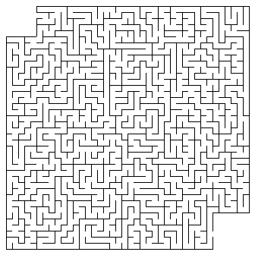

Name | Class | Description

Name | Class | Description

Name | Class | Description

Name | Class | Description

Please attach to the entry.

