Calaveras County Fair
& Jumping Frog Jubilee
ANIMAL WELFARE POLICY
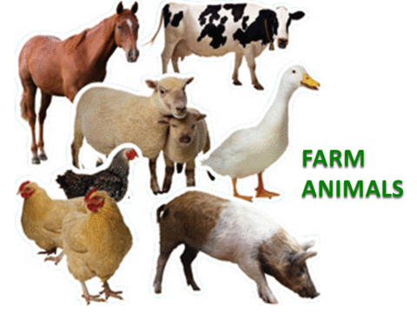

2018 Animal Welfare Committee

Official Spokesperson:
Laurie Giannini
CEO- Fair Manager
39th District Agricultural Association
Phone: 209-736-2561
Fax: 209-736-2476

39th District Agricultural Association: Board President
Gail Callan

Calaveras County Fair and Jumping Frog Jubilee: Entry Coordinator
Kasey Musachia

Calaveras County Fair Junior Livestock Committee: Chairman
Linda Olson

California Division of Fairs & Expositions:
Jay Carlson

Official Calaveras County Fair & Jumping Frog Jubilee Veterinarians: Angels Vet Hospital
Doctor Michael Hayes
Doctor Ray Sunseri

Calaveras County Farm Advisor:
Scott Oneto

Large Animal Representative-Chuck MacFarlane
Small Animal Representative-Amelia Tower

39th District Agricultural Association Rules Committee: Board of Directors
Darrin Mills, Steve Wooster

Animal Rights Organizations

Animal rights organizations equate animals with humans and believe both domestic and exotic animals are held captive by human beings. They are opposed to the use of animals for sport, fiber, food, entertainment or education.

Most animal’s rights activists do not eat meat or knowingly wear and or use products made from animal by-products. On the far left of the spectrum these individuals are radical. Their primary goal is to halt the use of animals for food production, fiber, recreation, medical research and entertainment.

Animal rights organizations have been capable of swaying public opinion because of their growing membership and interest / concern regarding animal welfare. Unfortunately, often individual photos and stories of abuse and inhumane treatment is portrayed as being representative of animal husbandry practices.

Policy

It is important that the Calaveras County Fair & Jumping Frog Jubilee and its representatives educate the public about animal care practices as they relate to exhibits, attractions and entertainment.

Any group or individuals wishing to express their views regarding animal welfare must comply with the free speech policy of the 39th District Agricultural Association.

Failure to adhere to the free speech policy may result in removal from the fairgrounds.
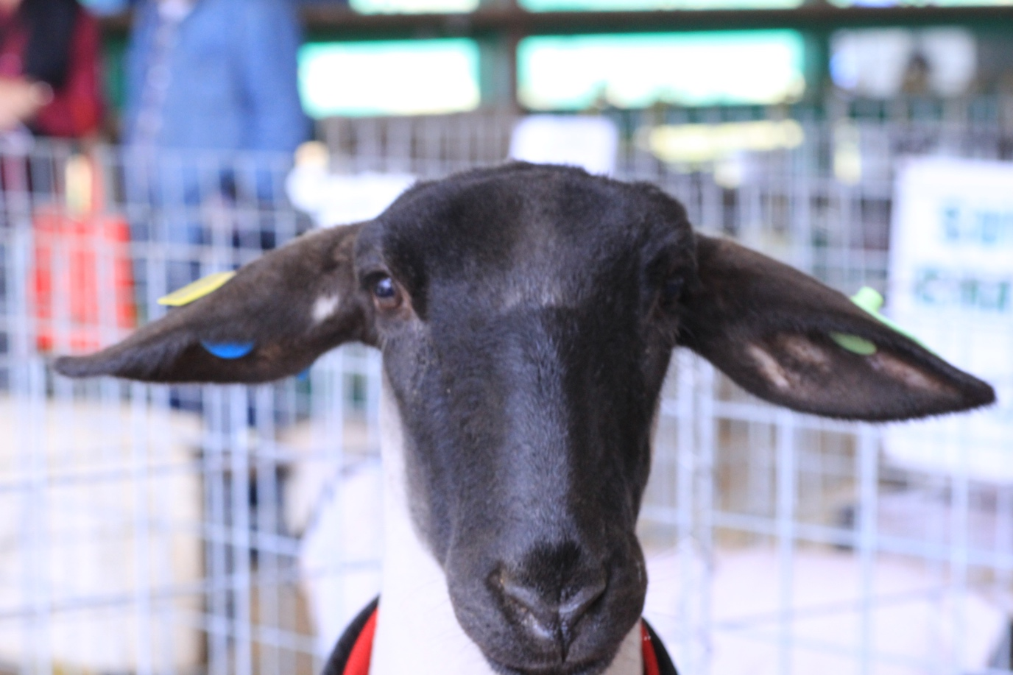

39th District Agricultural Association Policy Guidelines – First Amendment Rights Adopted 4/03

Findings:

The 39th District Agricultural Association hereby finds that these guidelines are intended to set forth in writing the Association’s longstanding policy governing the conduct of Association employees as well as members of the public under the First Amendment to the United States Constitution and Article I of the California Constitution, on the Association’s grounds.

These guidelines are not intended to enlarge upon nor create any rights guaranteed by existing law nor waive any defenses or rights available to the Association, nor do they represent any admission that the facilities of the Association are open as a public forum. It is the policy of this Association to allow within the parameters set forth herein, reasonable access to its grounds and designated free speech expression zones for demonstrations for free speech activity as allowed by the First Amendment to the Constitution and article I of the California Constitution. These provisions are intended to act as guidelines and reasonable regulation of time, place and manner and not content of speech.

Definitions:

“Public Forum” A public forum is an event wherein the facilities are available to members of the public for a free and open discussion or debate political on social issues.

“Limited Public Forum” A limited public forum is an event wherein the public is allowed access to a facility or facilities for specific purposes and where any public debate or discussion on political or social issues is focused on a particular subject or subjects. A limited public forum is not intended by the Association to generate a “public forum” as that term is defined herein.

“On site” – On site means any activities occurring within the grounds or parking lots of the 39th District Agricultural Association.

“Off Site” Off site refers to those public and private land surrounding the grounds of the Association.

Enclosed facility – An enclosed facility means any structure contained on the grounds of the Association and/or any other enclosed or semi enclosed building or structure whatsoever located on site.

“Free Expression Zone” A free expression zone is a designated area located on-site as established by the Association’s Board of Directors at which members of the public may be provided reasonable access in accordance with these guidelines for purposes of conducting free speech activities.

39th District Agricultural Association Policy Guidelines – First Amendment Rights Adopted 4/03

“Free Speech Activities” For purposes of these guidelines, “free speech activities” means individual or group display of signs other than specifically allowed herein; picketing, leafleting, collection of signatures or marching and any group activity involving the communication or expression, either orally or by conduct of views and/or grievances, and which has the effect and intent or propensity to express that view or grievance to others. As used in these guidelines, neither the definition of or limitations on “free speech activities” includes one on one voluntary discussions or individual wearing of buttons or symbolic clothing.

- “Fighting Words” – Fighting words are those words when addressed to the ordinary person are, as a matter of common knowledge, inherently likely to provoke an immediate violent reaction.

- “Obscene” Obscene means any sexually explicit material or communication which appeals to prurient interests and is patently offensive or abhorrent to the prevailing concepts of morality or decency of the community in which the Association exists.

- “Paid Gate” - a paid gate is that area of the grounds of the Association on site, the entry to which is restricted and predicated upon purchase of a ticket or entitlement prior to entry. This can include the general area of the Association enclosed by a fence, and/or any particular building with the Association’s grounds.

- “Sound Devices” Sound devices include any loudspeakers, megaphones or other devices, electrical or mechanical, which amplify or transmit sound waves. Included in this definition are forms of sound which are not mechanically amplified such as group chanting or singing.

2003.00 – Findings

The Association finds that due to the unique nature of the grounds of the Association, there is limited access necessitating creation of free expression zones. These zones are intended to provide reasonable access to those individuals or groups engaged in free speech activities while protecting the health and safety of the general public. The Association further finds that pedestrian traffic is confined to narrow walkways to and from parking areas where free speech expression zones are located and that is designated zones are designed to balance the interests of those individuals engaged in free speech activity and being given reasonable access to the general public, and the safety of the general public and the prevention of accidents or congestion which could lead to injury.

39th District Agricultural Association Policy Guidelines – First Amendment Rights Adopted 4/03

2004.00 – Free Expression Zones

The Association shall designate free expression zones on site for purposes of free expression activity. These zones shall be situated in such manner as to allow reasonable access to those members of the general public attending an event at the Association’s fairgrounds and shall be designate on a map. The zones shall be clearly marked and shall have a sign posted by the Association which states the views expressed by those utilizing these zones are not necessarily those of the Association. In locating the zone, the Association shall consider, public safety and shall located them in a way to avoid congestions, while maximizing public access by those engaged in free speech activities to those attending events. Use of these free expression zones shall be available on first come, first served basis, provided that those utilizing the free expression zones shall comply with the requirements and restrictions on time, place and manner set forth in Section 2005.

2005.00 – Conditions for use of Free Expression Zones

Whenever possible, those utilizing a free expression zone shall notify the management of the Association in advance to allow scheduling on a first come, first serve basis. If no advance notice is given, the Association shall attempt to provide space in free expression zones on a first come, first service basis. The Association reserves rights to assign such space or to move individuals or groups between or among zone depending upon the Association’s needs and to prevent any violence or misunderstanding due to use of said zones by individuals or groups with conflicting philosophies or where violence may reasonably be anticipated. Those utilizing free expression zones will abide by the following restrictions:

a. No signs or banner may be used which exceed 3 ‘ x 3’, in order to protect the safety of patrons and those engaged in free speech activities.

b. The following equipment may be brought in to a free expression zone for use in free expression activities:

1. A 6’ (six foot) long table (maximum length) and 4 chairs at each allowable location;

2. Signs which may be placed on the table or directly in front of the table only, subject to the size restriction noted above;

3. Necessary pens, pencils, paper clips, clip boards and leaflets or other materials to be disseminated to the public, provided that said material shall be secured to prevent littering.
39th District Agricultural Association Policy Guidelines – First Amendment Rights Adopted 4/03

c. No individual utilizing free expression zones shall state or imply that the views they express are the views of the Association.

d. No one utilizing a free expression zone shall block the movement of patrons, concessionaires, employees, lessees or those providing emergency services. No one shall physically restrain any other individual or block the free passage of such individuals or vehicles.
e. Patrons declining to listen, converse or provide a donation or signature of accept any item offered may not be touched or pursued once the individual has clearly indicated he or she wishes to be left alone

f. No free expression activity shall occur outside of the designated free expression zones or within 100’ (one hundred feet) of the entrance gates, or ticket booths.

g. No one utilizing a free expression zone shall interfere with parking attendants or individual patrons attempting to park cars, or operate in such manner as to obstruct the efficient and safe parking of cars by attendants or event patrons.

h. Those utilizing free expression zones shall do so in a way that they do not block, delay or hinder the free passage of any member of the public or obstruct or divert the ordinary flow of vehicular or pedestrian traffic.

i. No one shall utilize signs or displays or disseminate literature which employs fighting words, obscenities or presents gruesome, grisly or repulsive displays.

j. No one utilizing a free expression zone shall use or employ any sound device without prior written approval of the Association and the use of any permitted sound device shall not create a nuisance or noise of sufficient volume to impinge upon the hearing of patrons more that a few feet away from the free expression zone nor be used to broadcast any fighting words or obscenities.

k. There shall be no sale or offer for sale of any merchandise or services of any kind, including taking of orders for merchandise or services. Funds will not be demanded or requested in return for any written material. These prohibitions shall not be construed as preventing individuals utilizing free expression zones from soliciting voluntary contributions.

39th District Agricultural Association Policy Guidelines – First Amendment Rights Adopted 4/03

2006.00 – County Fair Free Speech Activities

During the annual Calaveras County Fair & Jumping Frog Jubilee, free expression activities may be allowed within the paid gate of the Association, if the individual or group wishing to engage in such activity obtains a booth space pursuant to lease or rental agreement subject to the same reasonable terms and conditions as are applied to any other person leasing such space.

2007.00 – Violations of Guidelines:

Anyone violating any of the provisions of these guidelines may be ejected from the grounds of the Association and such violations may be cause for termination of any free speech activity.

The Association reserves all legal rights and remedies.

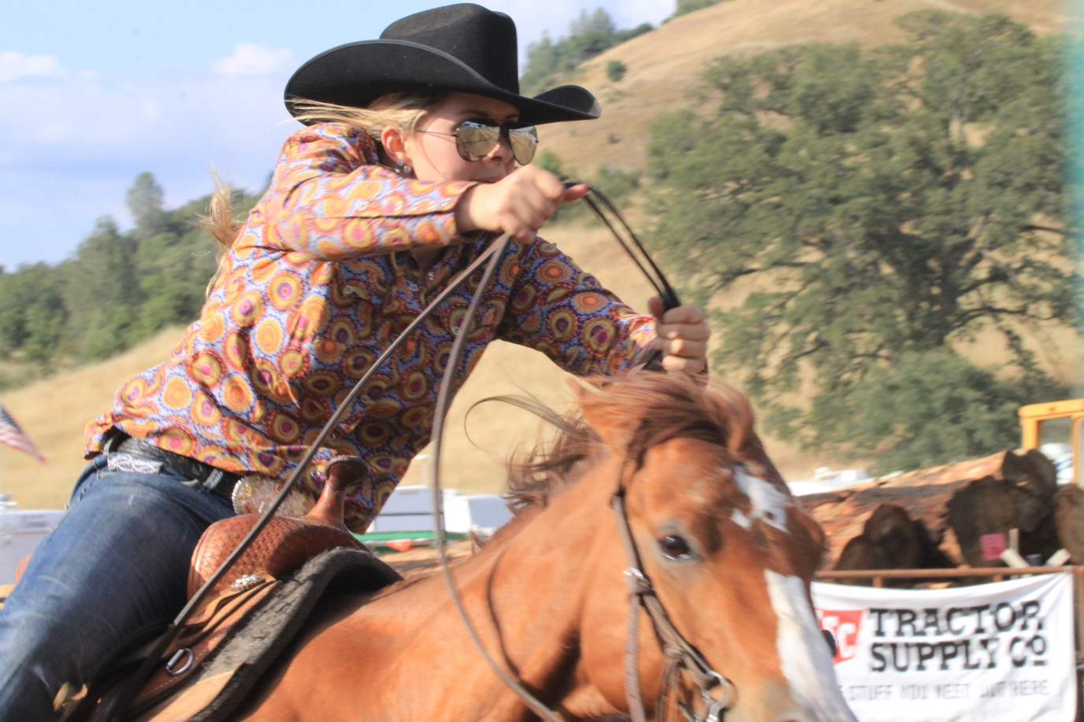

Directory -Animal Rights Organizations

ALF is an animal rights groups developed from the Band of Mercy Organization in Great Britain during the 1970’s.

Earth First, a radical environmental group, has begun focusing on animal rights in the Western Untied States.

Farm Sanctuary is a non-profit farm animal protection organization with more than 50,000 members. The group lobbies for protection of farm animals, investigates stockyards, packing houses etc. to expose abuse and inhumane treatment of farm animals.

Humane Farming Association is a San Francisco based groups with a large membership. Their chief concern is the confinement of livestock and their current focus is primarily veal calves and poultry.

PAWS(Performing Animal Welfare Society) was founded in 1985 by Pat Derby and Ed Stewart. Located in Calaveras and San Joaquin Counties in California, the PAWS facilities house rescued and abandoned animals such as tigers, bears, elephants and monkeys.

PETA, founded in the 1980’s, is based in Washington, D.C. This is the largest animal rights membership with a multi-million dollar budget. The organization advocates a vegetarian lifestyle. They are concerned with animal’s pain and suffering and feel animals have fundamental rights.

Society for the Prevention of Cruelty to Animals SPCA is primarily concerned with the humane treatment of animals.

Animal Welfare and Quality Assurance

Policy Statement

It is the policy of the 39th District Agriculture to ensure humane handling and treatment, housing and transportation of all animals on the fairgrounds. The Calaveras County Fair & Jumping Frog Jubilee works directly with the following agencies and organizations to facilitate appropriate methods:

California Department of Food and Agriculture

California Division of Fair’s & Expositions

California Department of Fish & Game

California Department of Health Services

University of California, Davis

Western Fair’s Association

Calaveras County Department of Agriculture

Calaveras County Zoo tonic Task Force

United States Department of Food and Agriculture

Calaveras County Farm Bureau

Calaveras County Cattlemen’s Association

Angels Camp Vet Hospital

Animal Welfare and Quality Assurance

Animal Welfare

Animal Welfare Committee

The Animal Welfare Committee is an advisory committee comprised of staff, industry professionals and private citizens. These intervals are called upon to review all animal related matters at the fairgrounds. Assist staff in developing procedures regarding handling and care of all animals residing at the fairgrounds and to review policy.

Species of animals and animal based programs:

Beef Cattle
Dairy Cattle
Sheep
Swine
Dogs
Horses
Goats
Llamas
Petting Zoo
Rabbits
Horse
Pony Rides
Rodeo Stock
Cavy
Frogs
Fish

Animal Exhibits

There has always been a conscientious concern for the treatment of animals at the Calaveras County Fair & Jumping Frog Jubilee. Animals are often the main attraction and the educational focus of the event. All animals must meet health requirements as set for the California Department of Food and Agriculture, Division of Fairs & Expositions. (See 2004 State Rules). Animal exhibits booked for the purpose of entertainment or fair attractions are encourage to provide educational material for the public about their animals husbandry practices.

Animal Welfare and Quality Assurance

Petting Zoo

In the event a petting zoo is booked as an attraction at the Calaveras County Fair & Jumping Frog Jubilee every effort will be made to see that the operator has a trained staff and practices appropriate animal husbandry policies and procedures. It is the intent of the Calaveras County Fair and Jumping Frog Jubilee that a petting zoo provide an educational hands on experience for the public.

Rodeo Animals

It is the intent of the Calaveras County Fair and Jumping Frog Jubilee to book a reputable rodeo company, belonging to a professional rodeo organization. The said company must adhere to practical humane animal husbandry practices. The company must have rules and regulations in place that prevents cruelty or unintentional mistreatment of animals. The fair’s veterinarian is always available during all rodeo performances.

Ethics Awareness and Quality Assurance

The Calaveras County Fair requires all junior exhibitors of livestock participate in an Ethics Awareness Class. Mini members are encourage but not required to attend.
The Random House Dictionary defines Ethics as the following A system of moral principles, the branch of philosophy dealing with the right and wrong of certain actions and the good and bad of such actions.

It is the intent of the program to assist parents and leaders in guiding the exhibitor to develop ethical livestock management skills and behavior. The program is a cooperative effort between the Calaveras County Fair, the UC Davis Cooperative Extension Office and Angels Camp Veterinary Hospital.

Behavior
Exhibitors are prohibited to show direct criticism or interference with the judge, show management or other exhibitors, breed representatives or show officials.
(Kindness is contagious)
Grooming
Junior exhibitors are expected to groom their animal while at the fair. Adults and non-exhibiting youth may assist an exhibitor or offer instruction.

Be sure to use safe products that are not harmful to the public or the animal. The products should not leave residues in the final product. (Meat) Do not use products that will harm the animal in anyway.

Animal Welfare and Quality Assurance

Ethics Awareness Continued

Changing the animal’s general structure of form by using an internal or external irritant, counter irritant or other substance is unethical and inhumane. (This includes udders)

Feeding an animal any liquid substance which is not normal for livestock is inhumane.

Drugs such as, tranquilizers, sedatives and depressants which alter the physical or psychological state of the animal is illegal unless prescribed by a licensed certified veterinarian. All drugs that are given to livestock must be approved by the Food and Drug Administration. A licensed veterinarian shall administer all medications to livestock during the Fair.

Surgically injecting foreign material under the skin or flesh to change the animals conformation (natural structure) or appearance in unethical.

Balancing an udder by abnormal means that includes the use of mechanical contrivance or the injection of fluid or drugs, setting the teats and/or occluding (sealing the ends) with a mechanical contrivance is unethical.

The following practices are considered inhumane, breaking tails, striking the animal to cause swelling, use of electrical contrivance or use of severe bits.

Ownership
All junior exhibitors with registered purebred or grade breeding animals must be under the project management and ownership by the exhibitor a minimum of 60 days prior to the opening day of the Fair. Market Animals, swine, sheep and turkeys must be under the exhibitor’s management 60 days, market beef, 150 days and market poultry 42 days prior to the opening day of the Calaveras County
Fair.

It is important for exhibitors to have a bill of sale. The bill of sale is the exhibitor’s proof of ownership. If the exhibitor is breeding his/her own project, a birth record should be kept by the exhibitor.

Purchasing market animals from a Junior Livestock Auction at a fair or livestock show is prohibited. Showing an animal for another exhibitor by claiming ownership in order to show in a specific class is prohibited.

Animal Welfare and Quality Assurance

Ethics Awareness Continued

Healthy Animals
The Fair management reserves the right to require animal health certificates. In order to inaugurate disease control (prevent spread), prevent unsafe conditions for the animals and exhibitors, a health inspection and diagnostic tests may be made before or after animals are on the fairgrounds. This will be determined by the Official Fair Veterinarian or the Fair’s appointed health official.

Junior Livestock Auction
At the time the animal is sold at the auction, the exhibitor is held directly responsible for animals that are rejected at the time at the processing center due to the presence of foreign residues.

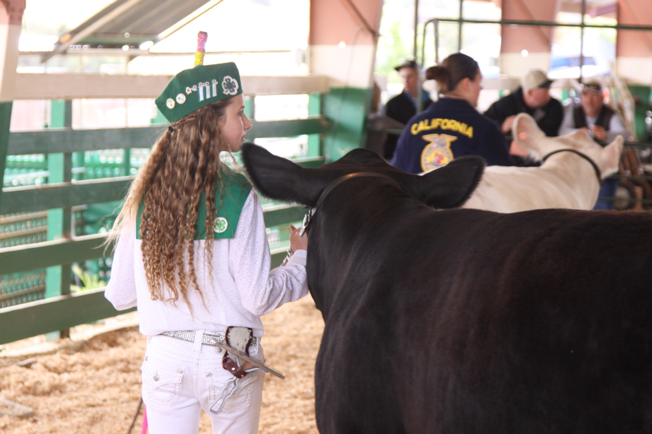

Animal Welfare and Quality Assurance

Frog Welfare Policy

Policy Statement

The Board of Directors of the 39th District Agricultural Association, governing body of the Calaveras County Fair & Jumping Frog Jubilee®, is dedicated to the prevention of cruelty to frogs, and advocates the safe and proper handling of frogs used in public events.

General Policy

It is the intention of the Board of Directors to ensure the safe and proper handling of all frogs involved in the Calaveras County Fair & Jumping Frog Jubilee and related events and activities.

This policy shall also apply to Frog Jump Contests officially sanctioned by the 39th District Agricultural Association, regardless of where they are held, as well as Special Frog Jumps and promotional activities held in conjunction with the Calaveras County Fair & Jumping Frog Jubilee.

This policy shall apply to two categories of frogs:
- Those frogs obtained by the association and under the control and supervision of the association.
- Those frogs obtained by others and brought to the Calaveras Fairgrounds for the Calaveras County Fair & Jumping Frog Jubilee or related events and activities.

General Procedures

Catching and Releasing

Persons wishing to catch frogs in the wild for use in Frog Jumping contests or other public events should make every effort to assure the safe and humane handling of the frogs. Following completion of the Frog Jumping contest frogs should not be released into the wild, frogs should be given to fair organizers and returned to a non-sensitive habitat as per recommendations by the California Department of Fish & Game.

Housing
Frogs shall be housed in a safe and humane manner that ensures their protection and comfort.

Animal Welfare and Quality Assurance

Frog Welfare Policy Continued

Transportation

Frogs shall be transported in a safe and humane manner. In the event frogs are to be transported across state lines or from one country to another, it is the responsibility of the person transporting the frogs to ensure their safety and comfort, and to know and obey all relevant laws and regulations.

Care of Sick or Injured Frogs

Anytime frogs are used in a Frog Jump or other public event, one person should be designated as responsible for the welfare of the frogs. In the event a frog involved in a public event appears to that designated person to be sick or injured, that frog shall be removed from the event immediately, isolated from other frogs, and cared for as much as possible.

Handling

Frogs shall be handled in a manner that prevents injury to the frog and maintains humane control so it will be difficult for the frog to escape into a potentially harmful environment. Although Mark Twain's original short story "The Celebrated Jumping Frog of Calaveras County" involved feeding buckshot to a frog in order to discourage it from jumping, the feeding or injecting of any unnatural, inappropriate or harmful objects to frogs for any reason is strictly prohibited.

Frog Jump Competitions

Frogs provided for a frog jumping competition or other public event should be transported and housed in a humane and safe manner. It is recommended that frogs used for a frog jumping competition be allowed to rest in an appropriate place after each jump and not be jumped more than three time in one day. Knowledgeable judges should be provided and given the authority to remove a frog from competition if the frog is too small, not in good health, or for any other humane reason.

Emergency Procedures
If a frog escapes during a public event, every effort should be made to recapture the frog without harming it and to avoid allowing it to reach a harmful or inappropriate environment.
Public events involving frogs should have an Emergency Response Plan that identifies:

- Individual or individuals responsible for the welfare of the frogs in the event of an emergency or disaster
- Evacuation plan, including who will evacuate the frogs, mode of transportation, where the frogs are to be taken.

Animal Welfare and Quality Assurance

Frog Welfare Policy Continued

Procedures for Violation of Frog Welfare Policy

In the event an individual or group is observed violating this Frog Welfare Policy or behaving in any manner that endangers frogs, the following actions should be taken.

The individual should be informed that his or her actions are endangering the frog(s) and have appropriate actions or behaviors explained.

If the individual or group continues to endanger the frog(s) after being informed as to proper frog handling procedures:

- That individual or group may be prohibited from handling, touching, jumping or having any contact with any frogs under the direct control and supervision of the association and association personnel

- That individual or group may be asked to leave the premises and, if necessary, may be escorted off the premises. The association shall be prepared to accept and care for any unwanted frogs brought to a frog jumping competition or other public event.

Procedures for Handling Complaints

In the event an individual or group expresses a concern or complaint about the handling of frogs at the Calaveras County Fair & Jumping Frog Jubilee or related events and activities, that individual or group shall:

- Be directed to the Fair Manager/CEO or and/or designee
- Be provided with free and open access to all frog facilities on the grounds or premises
- Be given a copy of this Frog Welfare Policy
- Have his or her concerns or complaints investigated and addressed immediate

If deemed necessary by the Fair Manager/CEO, a statement or press release on the matter shall be prepared as quickly as possible, and shall be a factual account of the issue and what, if anything, is being done to remedy the situation. A statement may also be prepared and issued if the complaint was investigated and found without merit. If necessary, the Fair Manager/CEO may schedule a press conference in order to quickly disseminate accurate and appropriate information.

All press releases, press conferences and other statements regarding a complaint, concern or emergency situation are to be approved by Fair Manager/CEO.

Frogs not Permitted to Participate

Under no circumstances will a frog listed on the endangered species list be permitted to participate in the Frog Jump.

Animal Welfare and Quality Assurance

Frog Welfare Policy Continued

California State Fish & Game Commission Codes and Regulations

Pertaining to Frogs and Frog Jumping
(Note: Fish & Game Codes are laws approved by the State Legislature. The California Code of Regulations contains regulations approved by the Fish & Game Commission, as authorized by the Fish & Game Code.)

Fish & Game Code (Division 6, Fish - Part 1, Generally, Chapter 7, Amphibian - Article 2, Frog-jumping contests; Enacted 1957) Historical Note: Similar to section 1356 of the Fish and Game Code of 1933, as added by Stats. 1955, c.149, p.603, §3.

§6880. Frog Jumping contest defined. As used in this article, "frog-jumping contest" means a contest generally and popularly known as a frog-jumping contest which is open to the public and is advertised or announced in a newspaper. (Stats.1957, c.456, p.1415, §6880.)

§6881. Taking frogs for jumping contest without license. Frogs to be used in frog-jumping contests shall be governed by this article only. Frog to be so used may be taken at any time and without a license or permit. (Stats.1957, c.456, p.1415, §6881.)

§6882. Presumption from mode of taking frogs. If the means for taking such frogs can, as normally used, seriously injure the frog, it shall be conclusively presumed the taking is not for the purposes of a frog-jumping contest. (Stats.1957, c.456, p.1415, §6882.)

§6883. Death of jumping frog. Any person may possess any number of live frogs to use in frog-jumping contests, but if such a frog dies or is killed, it must be destroyed as soon as possible, and may not be eaten or otherwise used for any purpose. (Stats.1957, c.456, p.1415, §6883.)

§6884. Frogs excluded from article. A frog which is not kept in a manner which is reasonable to preserve its life is not within the coverage of this article. (Stats.1957, c.456, p.1415, §6884.

§6885. Article not subject to modification by regulation. The commission has no power to modify the provisions of this article by any order, rule, or regulation. (Stats.1957, c.456, p.1415, §6885.)

California Code of Regulations
Subsection (i) of Section 658, Title 14, Amend 658, effective Feb. 24, 1995

(i) Restricted sale. Except for bullfrogs sold, leased, or rented for use in frog jumping contests as defined in Fish and Game Code section 6880, bullfrogs taken under authority of a permit issued pursuant to this section may be sold only to bona fide scientific or educational institutions and may be used only for scientific or educational purposes, and may not be sold, purchased or traded for any other use.

Summary of Regulatory Action. The regulatory action authorizes scientific supply houses which have permits to sell bullfrogs to bona fide scientific or educational institutions to also sell bullfrogs for use in frog jumping contests.

