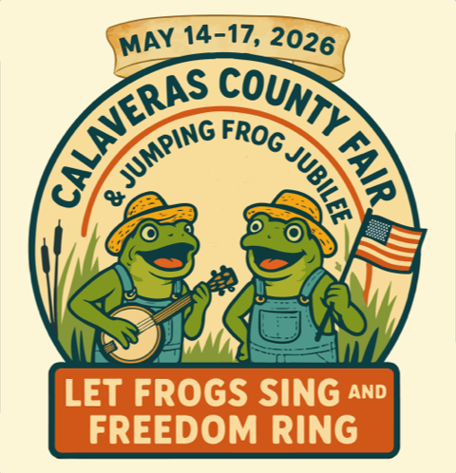

If You GREW It, DREW It, or SEWED It — YOU SHOULD SHOW It!
Calling all young creators!
If you grew it, drew it, or sewed it, the Calaveras County Fair & Jumping Frog Jubilee wants to showcase your hard work.

General Information
This special competition is open to students from preschool through sixth grade.
Entries must be delivered to Tom Sawyer Hall with the entry coupon attached on:
• May 5 from 12 PM to 7 PM
• May 6 from 12 PM to 6 PM
All entries must be picked up on May 18, 2026, between 10 AM and 6 PM

Class 1 – Hobbies: Includes woodworking, latch hook rugs, jewelry, cross stitch, Lego creations, photos. (All photos must be matted, no glass or frames. Construction paper and/or poster board is fine for matting.)
Class 2 – Arts & Crafts: Includes pencil drawings, oil paintings, watercolors, pen & Ink drawings, ceramics, bird houses, wind chimes and more. (All art must be matted, no glass or frames)
Class 3 – School Projects: Includes missions, pyramids, State reports, Family History reports and book reports.

Class 4 – Science Projects: Includes observation and experiment projects.
Just for Fun
Words to Find:
- FROGTOWN
- JUBILEE
- RODEO
- CORNDOG
- EXHIBITS
- MIDWAY
- CARNIVAL
- RIBBON
- PIGRACES
- QUEEN
- FAMILY
- ARENA
- LOVE
- SEE
- WIN
- GET
- GAIN
- CAP
- LIFT
- WIN

F | R | O | G | T | O | W | N | L | Q | M | X
A | R | E | N | A | I | A | I | U | B | E | O
M | C | A | R | N | I | V | A | L | T | D | D
I | C | O | R | N | D | O | G | S | M | D | U
L | A | J | U | B | I | L | E | E | E | W | S
Y | P | I | G | R | A | C | E | S | T | A | I
E | X | H | I | B | I | T | S | F | I | R | E
Q | U | E | E | N | P | R | I | B | B | O | N
M | I | D | W | A | Y | L | O | V | E | F | E
R | O | D | E | O | F | A | M | I | L | Y | S

All projects must have an entry coupon attached to it.

ENTRY COUPON
Name | Class | Description

Name | Class | Description

Name | Class | Description

Name | Class | Description

Name | Class | Description

Name | Class | Description

