**Special Contest**

**Soy un abuelo orgulloso**

Muchos abuelos de nuestro condado tienen Many grandparents in our county have talented grandkids that live out of the area and send special creations to their grandparents. This division is dedicated to those special grandparents and grandkids.

* Danish System of Judging
* List Grandchild’s names and ages in the description.

Department 1 DIVISION 102– I’m a Proud Grandparent

Class

1. Handmade Item from Grandchild, Specify (Ex: Art work, Crafts, Photography, Writing)

Entries and entry forms must be delivered to Tom Sawyer Hall

Tuesday, May 6th from 12 PM to 7 PM or Wednesday, May 7th from 10 AM to 8 PM.

**PICK UP ENTRIES MONDAY, MAY 19th 12 PM TO 6 PM**

Grandchild Name and age:_______________________________________________________________________

Description of item:______________________________________________________________________________

Grandparent Name:___________________________________________________Phone:____________________

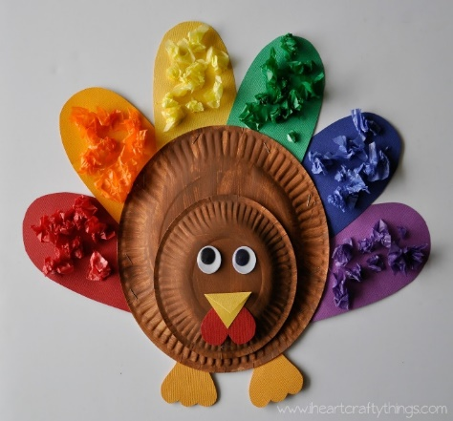Grandparent Mailing address:______________________________________________________________________ Town:_______________, CA Zip:______________________________________________________________________

**View All our Fair info at frogtown.org/county-fair**